Select * from actor;

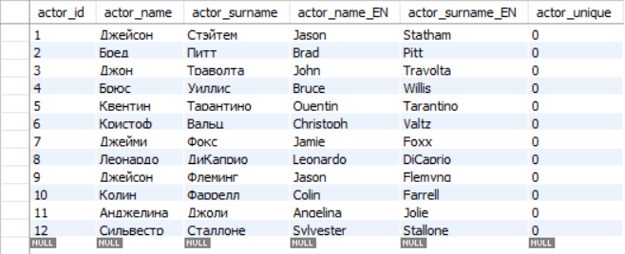

Select * from director;

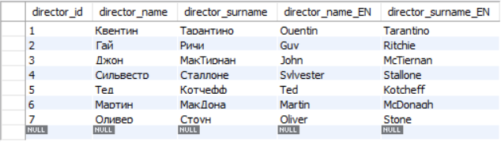

Select * from film;

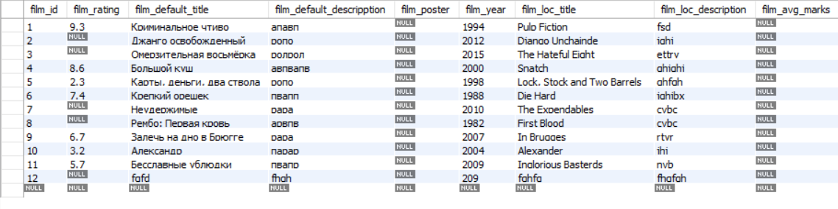

Select * from film_genre;

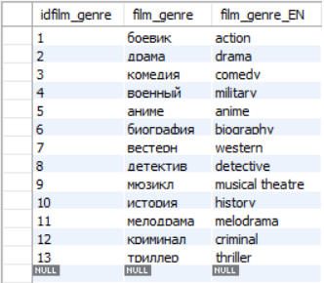

Select * actor_has_film;



Select * from director_has_film;



Select * from film_has_genre;

